|  |  |
| --- | --- |
|  | **Pimpri Chinchwad Education Trust’s**  **Pimpri Chinchwad College of Engineering** |

|  |
| --- |
| **Practical Assignment Solution-1** |

**Roll No: 21**

**Name of Student: Kiran Chavan Submission Date:** 24 / 02 /2021

1. Create a Java program to accept 10 numbers from user, store in an array. Find the

second largest and second smallest number from it. Use Scanner class to accept

input from user.

**Solution:**

import java.util.*;

public class A1Q1{

public static void main(String arg[]){

int i,n=10;

int[] a = new int[n];

Scanner sn = new Scanner(System.in);

System.out.println("Enter the 10 numbers : ");

for(i=0;i<n;i++){

a[i]= sn.nextInt();

}

System.out.print("Elements are : ");

for(i=0;i<n;i++){

System.out.print(a[i]+" ");

}

System.out.println();

for(i=0;i<n;i++){

for(int j=i+1;j<n;j++){

if(a[i]>a[j]){

int temp = a[i];

a[i] = a[j];

a[j] = temp;

}

}

}

System.out.print("Sorted Elements are : ");

for(i=0;i<n;i++){

System.out.print(a[i]+" ");

}

System.out.println();

System.out.println("Second Largest No is :"+a[n-2]);

System.out.println("Second Smallest No is :"+a[1]);

}

}

**Output:**

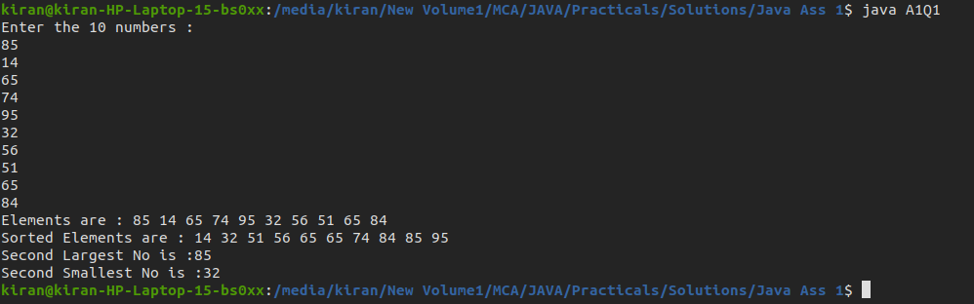

2. Create a Java program to accept number of strings from user and sort them in

alphabetical order. Use String class to store accepted string from user.

**Solution:**

import java.util.*;

class A1Q2{

public static void main(String args[]){

String s[] = new String[100];

Scanner sn = new Scanner(System.in);

System.out.print("Enter the number to be accept the String :");

int n = sn.nextInt();

System.out.println("Enter the "+n+" Strings :");

for(int i=0;i<n;i++){

s[i] = sn.next();

}

System.out.print("Strings are :");

for(int i=0;i<n;i++){

System.out.print(s[i]+" ");

}

System.out.println();

for(int i=0;i<n;i++){

for(int j=i+1;j<n;j++){

if(s[i].compareToIgnoreCase(s[j])>0){

String temp = s[i];

s[i] = s[j];

s[j] = temp;

}

}

}

System.out.print("Sorted String Array :");

for(int i=0;i<n;i++){

System.out.print(s[i]+" ");

}

System.out.println();

}

}

**Output:**

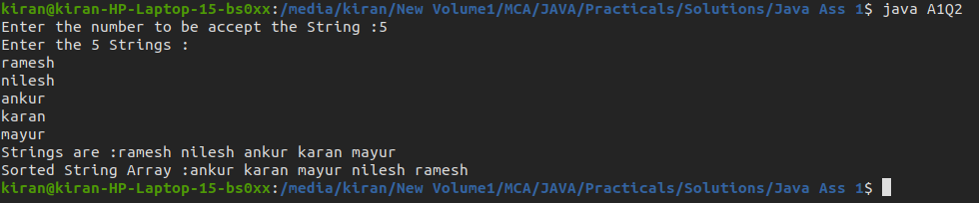

3. Create a Java program to accept two numbers from user, find GCD and LCM of both

the numbers. Use Scanner class to accept two numbers from user.

**Solution:**

import java.util.*;

class A1Q3{

public static void main(String args[]){

Scanner sn = new Scanner(System.in);

System.out.print("Enter first Number :");

int x = sn.nextInt();

System.out.print("Enter Second Number :");

int y = sn.nextInt();

int gcd = 1;

for(int i=1;i<=x && i<=y;i++){

if(x%i==0 && y%i==0){

gcd = i;

}

}

System.out.println("GCD of "+x+" & "+y+" is :"+ gcd);

int lcm = (x*y)/gcd;

System.out.println("LCM of "+x+" & "+y+" is : "+lcm);

}

}

**Output:**

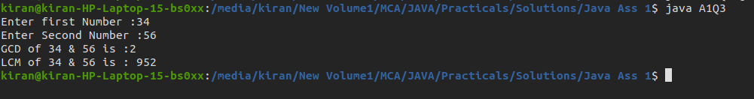

4. Create a Java program to accept a string from user and find the occurrences of

characters in string.

Example:

Input: “beginner”

Output: Occurrence of b is: 1

Occurrence of e is: 2

Occurrence of g is: 1

- - - -

- - - -

**Solution:**

import java.util.*;

class A1Q4{

public static void main(String args[]){

Scanner sn = new Scanner(System.in);

System.out.print("Enter the String : ");

String str = sn.nextLine();

int a[] = new int [256];

for(int i=0;i<str.length();i++){

a[str.charAt(i)]++;

}

str = str.replace(" ","");

char ch[] = str.toCharArray();

for(int i=0;i<ch.length;i++){

int cnt = 0;

for(int j=0;j<ch.length;j++){

if(j<i && ch[i]==ch[j])

break;

if(ch[i]==ch[j])

cnt++;

}

if(cnt>0)

System.out.println("Occurance of "+ch[i]+" is "+cnt);

}

}

}

**Output:**

